REQUEST FOR QUOTATION (RFQ) |  | Supplier’s Stamp/Signature:
Closing Date | : 18 November 2025 | Supplier’s Stamp/Signature:
Email Submission | : box7@belts.com.bn | Supplier’s Stamp/Signature:
BELTS Ref | : BELTS/HCCS/RFQ/2025/028 | Supplier’s Stamp/Signature:
Date of Submission | : Click here to enter text. | Supplier’s Stamp/Signature:
Supplier/Quote Ref | : Click here to enter text. | Supplier’s Stamp/Signature:

Company Name | Click here to enter text.
Address | Click here to enter text.
Phone | Office: Click here to enter text. Mobile: Click here to enter text.

No. | Item Description |  | Delivery Period |  | Qty/UoM | Unit Price |  | Total Price
1 | Provision of Company T-Shirt:  See attached Annex A for Draft Design.  Material: Dri-Fit  Color: Black  Printing: White  Font: Exo 2  Sleeve: Short
1a | Size : XS - 2XL |  | 1 month after issuance of PO |  | 100 / Ea | Click here to enter text. |  | Click here to enter text.
1b | Size : 3XL and above |  | 1 month after issuance of PO |  | 50 / Ea | Click here to enter text. |  | Click here to enter text.
2 | Material: Dri-Fit  Color: Black  Printing: White  Font: Exo 2  Sleeve: Long
2a | Size : XS - 2XL |  | 1 month after issuance of PO |  | 100 / Ea | Click here to enter text. |  | Click here to enter text.
2b | Size : 3XL and above |  | 1 month after issuance of PO |  | 50 / Ea | Click here to enter text. |  | Click here to enter text.
Note:
- Please provide the quotation with pictures.
- For any questions or enquiries kindly e-Mail directly to rfq_enquiry@belts.com.bn
MANDATORY  Suppliers are to provide with the Packaging Dimension,  Measurement & Weight - in Standard measurement in Meter, Feet,  Inches, Cm, Mm, Kg, GM |  |  |  | TOTAL PRICE |  |  | Click here to enter text.
Freight Term (EXW,CIF,ETC) |  |  |  |  |  |  | Click here to enter text.
Freight Charges (IF APPLICABLE) |  |  |  |  |  |  | Click here to enter text.
Any other charges please state |  |  |  |  |  |  | Click here to enter text.
GRAND TOTAL |  |  |  |  |  |  | Click here to enter text.
Currency Code : |  | BND
Price Validity  (Minimum 9 Months) : |  | Click here to enter text.
Payment Terms : |  | 30 DAYS CREDIT
Warranty : |  | Click here to enter text.
Mode of Delivery : |  | Click here to enter text.
Delivery Period : |  | Click here to enter text.
Country of Manufactured : |  | Click here to enter text.
Remarks: |  | Click here to enter text.

DESIGN “A”
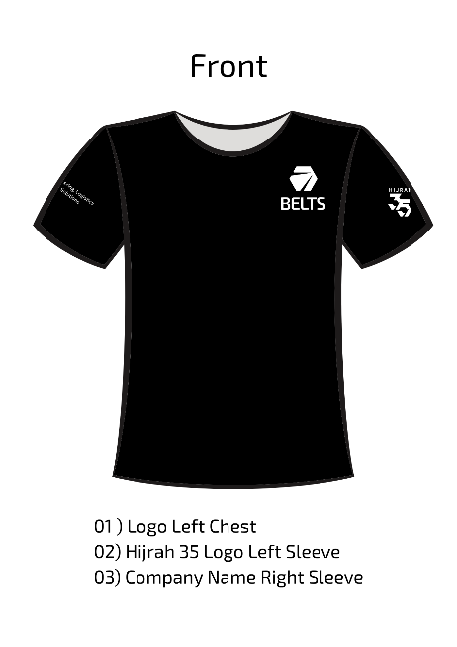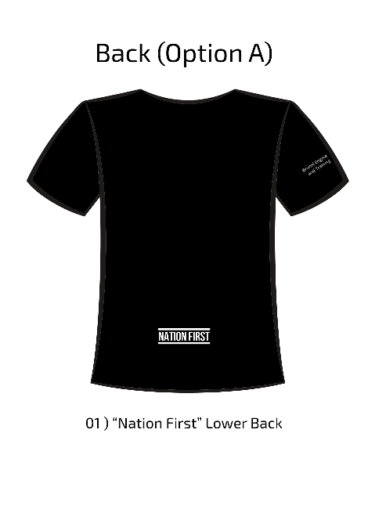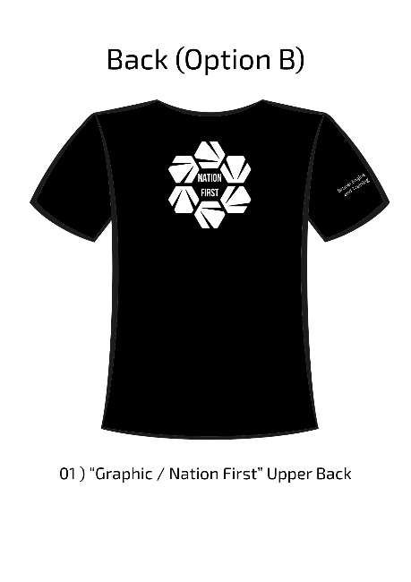

DESIGN”B”
