REQUEST FOR QUOTATION (RFQ) |  | Supplier’s Stamp/Signature:
Closing Date | : 29 September 2025 | Supplier’s Stamp/Signature:
Email Submission | : box1@belts.com.bn | Supplier’s Stamp/Signature:
BELTS Ref | : BELTS/05J/2526/28 | Supplier’s Stamp/Signature:
Date of Submission | : Click here to enter text. | Supplier’s Stamp/Signature:
Supplier/Quote Ref | : Click here to enter text. | Supplier’s Stamp/Signature:

Company Name | Click here to enter text.
Address | Click here to enter text.
Phone | Office: Click here to enter text. Mobile: Click here to enter text.

No. | Item Description | Delivery Period | Qty/UoM |  | Unit Price | Total Price
1. | Supply, Installation, Configuration, Testing and Commissioning of CCTV Systems  Site Location:  State Medical Store  Ministry of Health  Spg 433, Rimba Highway,  Kampong Madaras  Bandar Seri Begawan BE3119  Brunei Darussalam  Number of Cameras: 9  Number of NVR: 1  Refer Annex A1 & A2 below for placement of cameras  Functional Requirement:  - Movement recording (minimum retention period of 90days)  - Optional: 1 year recording retention period  - Access Control  - Role Base access permission to administer NVR (Admin/Guest)  - Logging and monitoring  - Real Time access logging with time stamp and user ID  - Extract videos  - Scalability  - Additional cameras in the future  - Upgradable storage  Optional:  Number 40” TV: 1  Number of Switch: 1  Remarks:  Site visits are schedule on the following day:  Date: Monday, 22nd September 2025  Time: 9am to 11am and 2pm to 4pm  Location:  State Medical Store  Ministry of Health  Spg 433, Rimba Highway, Kampong Madaras  Bandar Seri Begawan BE3119  Brunei Darussalam  *Please bring you IC for visitor pass at guard house*  Any enquiries for site visit ONLY please email/contact us at helpdesk@belts.com.bn or 2242700 ext 147 |  | /Lot |  | Click here to enter text. | Click here to enter text.
Delivery Address:

State Medical Store
Ministry of Health
Spg 433, Rimba Highway, Kampong Madaras
Bandar Seri Begawan BE3119
Brunei Darussalam

MANDATORY  Suppliers are to provide with the Packaging Dimension,  Measurement & Weight - in Standard measurement in Meter, Feet,  Inches, Cm, Mm, Kg, GM |  |  |  | TOTAL PRICE |  | Click here to enter text.
Freight Term (EXW,CIF,ETC) |  |  |  |  |  | Click here to enter text.
Freight Charges (IF APPLICABLE) |  |  |  |  |  | Click here to enter text.
Any other charges please state |  |  |  |  |  | Click here to enter text.
GRAND TOTAL |  |  |  |  |  | Click here to enter text.

Currency Code : | BND
Price Validity  (Minimum 9 Months) : | Click here to enter text.
Payment Terms : | 30 DAYS CREDIT
Warranty : | Click here to enter text.
Mode of Delivery : | Click here to enter text.
Delivery Period : | Click here to enter text.
Country of Manufactured : | Click here to enter text.
Remarks: | Click here to enter text.

Annex A1
Indoor
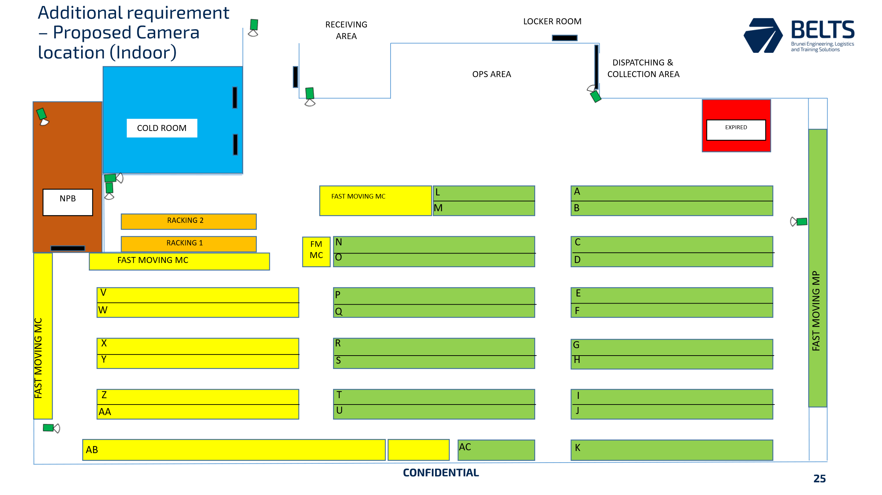

Annex A2
Outdoor
