REQUEST FOR QUOTATION (RFQ) |  | Supplier’s Stamp/Signature:
Closing Date | : 16 September 2025
Email Submission | : box2@belts.com.bn
BELTS Ref | : BELTS/HCCS/RFQ/2025/024
Date of Submission | : Click here to enter text.
Supplier/Quote Ref | : Click here to enter text.

Company Name | Click here to enter text.
Address | Click here to enter text.
Phone | Office: Click here to enter text. Mobile: Click here to enter text.

No. | Item Description |  | Delivery Period |  | Qty/UoM | Unit Price |  | Total Price
1 | Supply and Delivery of  Foldable/moveable working /meeting Table  Purpose of Table:  To be used for meeting / discussion and training like classroom  Table Specifications:  Color: White  Measurement Size : 120cm(l) x 60cm(W) x 75cm(H)  Size of the room is approximate: -  42 Ft 7 Inch x 12 Ft 7 Inch  Location Address:  Brunei Engineering Logistics and Training Solutions Sdn Bhd (BELTS)  Level 5, Setia Kenangan Complex,  Kg Kiulap BE1518  Bandar Seri Begawan,  Brunei Darussalam  Sample Picture(s):  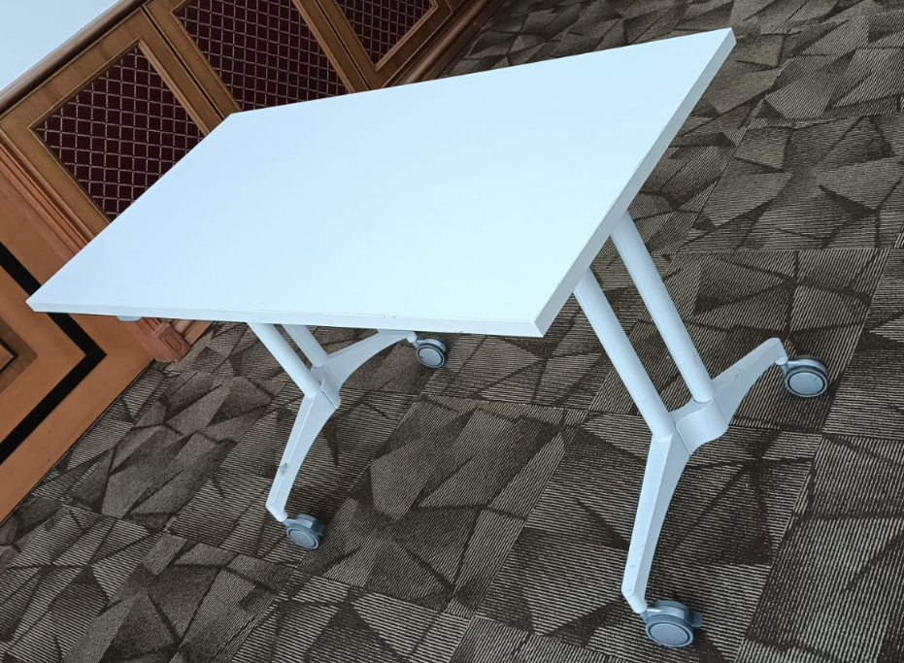  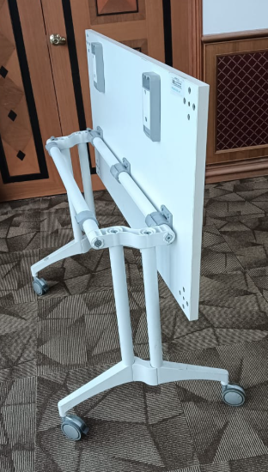 |  | 3 working days after PO issuance |  | 12 Pcs | Click here to enter text. |  | Click here to enter text.
Note:
- Please provide the quotation with pictures.
- For any site visit purposes kindly e-Mail your date & time schedule to admincorp@belts.com.bn
- For any questions or enquiries kindly e-Mail directly to rfq_enquiry@belts.com.bn
- Contractor must implement safety measures to protect workers and the public during installation/delivery work.
- Vendors/contractors must adhere to regulatory SHENA safety rules and regulations.

MANDATORY  Suppliers are to provide with the Packaging Dimension,  Measurement & Weight - in Standard measurement in Meter, Feet,  Inches, Cm, Mm, Kg, GM |  |  |  | TOTAL PRICE |  |  | Click here to enter text.
Freight Term (EXW,CIF,ETC) |  |  |  |  |  |  | Click here to enter text.
Freight Charges (IF APPLICABLE) |  |  |  |  |  |  | Click here to enter text.
Any other charges please state |  |  |  |  |  |  | Click here to enter text.
GRAND TOTAL |  |  |  |  |  |  | Click here to enter text.
Currency Code : |  | BND
Price Validity  (Minimum 9 Months) : |  | Click here to enter text.
Payment Terms : |  | 30 DAYS CREDIT
Warranty : |  | Click here to enter text.
Mode of Delivery : |  | Click here to enter text.
Delivery Period : |  | Click here to enter text.
Country of Manufactured : |  | Click here to enter text.
Remarks: |  | Click here to enter text.

